High Availability (HA): Ensuring Uptime Even If a Failure Happens
High Availability means your application remains online even if some components fail.
🔹 HA Components for ChatApp
- Multi-AZ Deployment (Redundancy across different AWS zones)
2.Elastic Load Balancer (ELB) (Automatically distributes traffic)
3.RDS Multi-AZ for MySQL (Keeps database online even if a DB server fails)
- 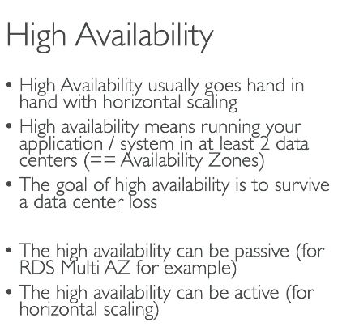

Scalability: Handling More Users Without Performance Issues
Scalability ensures your app can handle increasing users without slowdowns.
Scaling Strategies for ChatApp
Type | How It Works
Vertical Scaling (Scaling Up) | Upgrading EC2 instance type (More CPU/RAM)
Horizontal Scaling (Scaling Out) | Adding more instances behind Load Balancer
Database Read Replicas | Using Amazon RDS Read Replicas to offload traffic
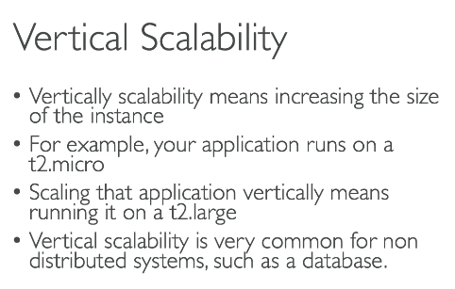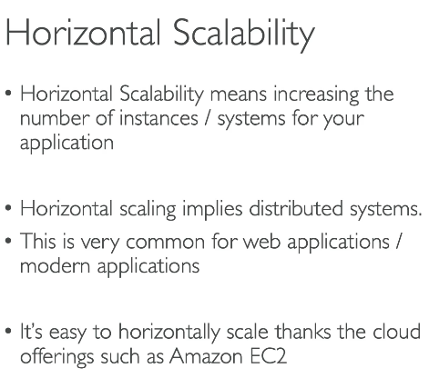

Elastic Load Balancer (ELB) in AWS: Ensuring High Availability for ChatApp
🔹 What is Elastic Load Balancer (ELB)?
Elastic Load Balancer (ELB) is a managed AWS service that distributes incoming traffic across multiple EC2 instances, ensuring:
✅ High Availability – If one instance fails, traffic is routed to healthy instances
✅ Scalability – Handles sudden increases in traffic
✅ Security – Protects against failures & supports SSL/TLS
Types of Elastic Load Balancers in AWS
ELB Type | Use Case
Application Load Balancer (ALB) | Best for web apps (Layer 7 - HTTP/HTTPS)
Network Load Balancer (NLB) | Best for high-performance, low-latency apps (Layer 4 - TCP/UDP)
Classic Load Balancer (CLB) | Older generation, supports basic load balancing
💡 For ChatApp, we use ALB since it handles HTTP/HTTPS traffic efficiently.
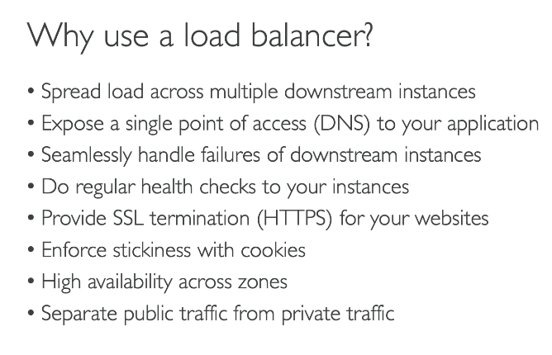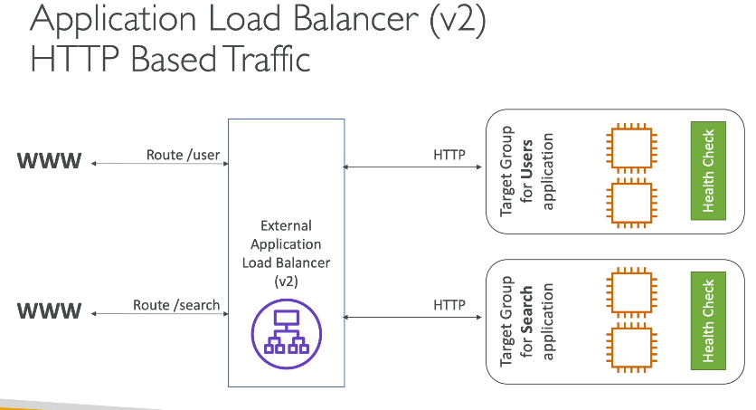
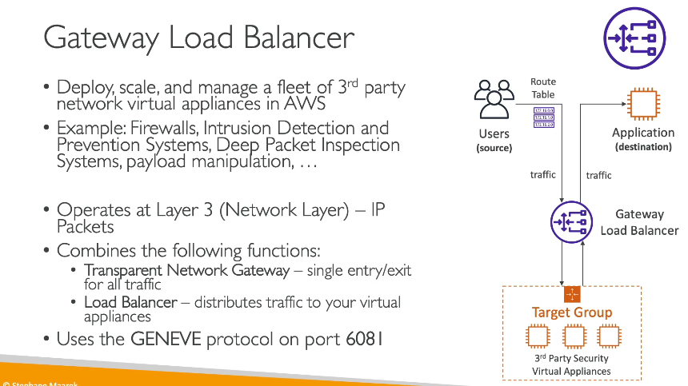

Sticky Sessions in AWS Elastic Load Balancer (ELB)
Sticky Sessions (also called Session Persistence) in AWS ensure that a user’s requests are routed to the same backend instance for a certain period instead of being distributed randomly.
🔹 Why is it important?
Some applications (like your ChatApp) require user sessions to remain on the same backend instance to maintain user state.
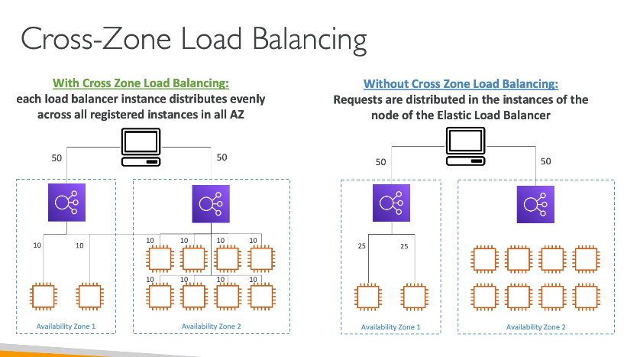

SSL/TLS Certificates in AWS Elastic Load Balancer (ELB)
🔹 What is SSL/TLS in ELB?
SSL (Secure Sockets Layer) and TLS (Transport Layer Security) encrypt traffic between clients and your Load Balancer (ELB), ensuring secure communication.

🔹 Why Use SSL/TLS in ELB?
✅ Encrypts data between users and your ChatApp
✅ Ensures security against attacks (e.g., MITM attacks)
✅ Compliance with security standards (PCI DSS, HIPAA)
✅ Improves SEO (Google prefers HTTPS over HTTP)

🔹 Scenario: Securing Your ChatApp with SSL/TLS
You have a ChatApp hosted behind an Application Load Balancer (ALB). Users access it via https://chatapp.com.
- Without SSL/TLS: 🔴 Data is sent in plaintext, making it vulnerable to attacks
- With SSL/TLS: ✅ Data is encrypted, making it secure

What is Server Name Indication (SNI)?
SNI (Server Name Indication) allows multiple SSL/TLS certificates to be used on a single Load Balancer or single IP address.
🔹 Why is SNI Important?
✅ Hosts multiple domains on the same ELB with different SSL certificates
✅ Saves costs by avoiding multiple Load Balancers
✅ Improves security by encrypting data for multiple websites

Connection Draining in AWS Elastic Load Balancer (ELB)
🔹 What is Connection Draining?
Connection Draining ensures that existing connections to a deregistering or unhealthy instance are gracefully completed before terminating or stopping the instance.
💡 Without Connection Draining
🚨 If an instance is removed from the Load Balancer, active users may experience dropped connections.
✅ With Connection Draining
The Load Balancer waits for ongoing requests to complete before stopping new traffic.
🔹 Scenario: Connection Draining in Your ChatApp
Your ChatApp is running behind an Application Load Balancer (ALB) with 3 EC2 instances handling user traffic.
What happens when you update or terminate an instance?
🔴 Without Connection Draining:
- A user sending a message or uploading a file may get abruptly disconnected if the instance is removed.
✅ With Connection Draining:
- The ELB waits for the user’s request to complete before removing the instance from rotation.
How to Enable Connection Draining in AWS ELB?
1️. Go to AWS EC2 Console → Load Balancers
2️. Select your Load Balancer
3️. Navigate to the Target Groups tab
4️. Choose your target group and click Edit Attributes
5️. Enable Connection Draining (Deregistration Delay)
6️. Set a timeout value (e.g., 300 seconds for 5 minutes)
7️. Save Changes.
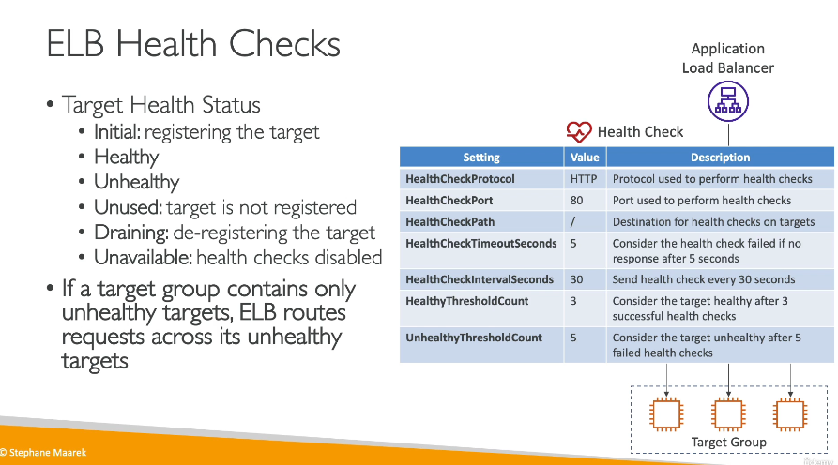

What is an Auto Scaling Group?
An Auto Scaling Group (ASG) automatically increases or decreases the number of EC2 instances based on demand.
💡 Why use ASG?
✅ Ensures high availability
✅ Automatically scales instances based on traffic load
✅ Reduces costs by terminating unused instances
What are Scaling Policies?
Scaling policies define how and when an Auto Scaling Group (ASG) should add or remove EC2 instances based on metrics like CPU utilization, request count, or memory usage.
💡 Why use Scaling Policies?
✅ Automatically adjusts instances based on demand
✅ Ensures high availability and performance
✅ Reduces costs by removing unused instances

🔹 Types of ASG Scaling Policies
1. Target Tracking Scaling Policy (Recommended)
- Automatically adjusts the number of instances to maintain a target metric.
- Example: Keep CPU Utilization at 50%
- AWS manages scaling dynamically for optimal efficiency.
💡 Example for ChatApp
- Goal: Maintain CPU at 50%
- If CPU > 50% → ASG adds instances
- If CPU < 50% → ASG removes instances
✅ Best for applications with unpredictable traffic

2. Step Scaling Policy
- Increases or decreases instances step by step based on CloudWatch alarms.
💡 Example for ChatApp
- If CPU > 70% for 5 minutes → Add 2 instances
- If CPU < 40% for 5 minutes → Remove 1 instance
✅ Best for handling sudden traffic spikes

3.Scheduled Scaling Policy
- Launches or terminates instances at a fixed time (good for predictable workloads).
💡 Example for ChatApp
- Morning (8 AM - 10 AM) → Increase to 5 instances (Peak traffic)
- Night (11 PM - 5 AM) → Reduce to 1 instance (Low traffic)
✅ Best for applications with predictable traffic patterns

4. Simple Scaling Policy (Basic)
- Adds or removes a fixed number of instances when a CloudWatch alarm is triggered.
💡 Example for ChatApp
- If CPU > 70% → Add 1 instance
- If CPU < 40% → Remove 1 instance
✅ Less efficient than Target Tracking but works for basic scaling needs

What are ASG Lifecycle Hooks?
Lifecycle hooks pause an instance at specific stages of its lifecycle, allowing you to perform custom actions before launching or terminating an instance.
🔹 Why use Lifecycle Hooks?
✅ Run custom scripts before an instance is added to a Load Balancer.
✅ Collect logs or run clean-up tasks before termination.
✅ Prevent traffic loss by ensuring the app is ready before receiving requests.

